**P3 – Illustrate the operation of different sensors and output devices**

**Introduction**

In this assignment, I will be operating with each of the different sensors. First, I am going to explain what a sensor is followed by the examples of sensors. I am going to explain temperature, sound and light. In addition, I will be using ‘SCRATCH’ to demonstrate how they are used. I will be showing screenshots of it by each step of how I used the sensors.

**What is a sensor?**

A sensor is a machine that is specifically designed to detect any action and respond to it. It could detect noises, movements. It depends which sensor because all of the sensors are different e.g., a GPS picks up signal and shows the user where you are meant to go.

**Temperature sensor**

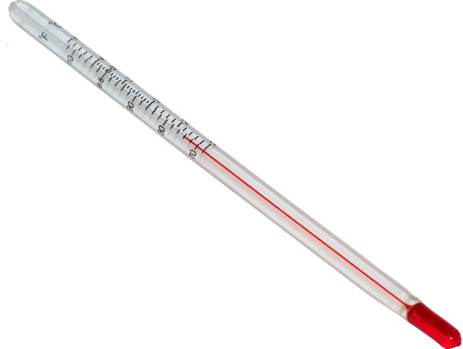A temperature sensor simply detect the temperature of the room. This sensor gathers data and it is converted so that the observer can understand what the temperature of the room is e.g. seven would be positive and hot, but minus five would be cold. This could be used in any science experiment and it depends the temperature of the surroundings. For example, in the UK, if it is cold, any user can use the temperature sensor and it would detect a minus if it were cold. If it is hot, it will be positive. A temperature sensor can be also known as thermometer. The image shows how a temperature sensor looks like. The numbers are small therefore; the user needs to be accurate whilst measuring the temperature of the specific item.

**Touch sensor**

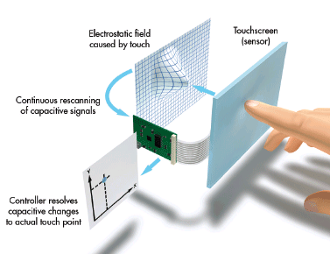A touch sensor simply detects anything physically being touched onto the sensor just like a switch. As any switch, if you do not press the sensor, nothing will happen. Unless the sensor has been pressed, it will respond otherwise it would not. If any human being touches the light, it will respond by turning the light on or off. Similarly, when the sensor has been pressed, it will return it depending on what it has been programmed to do. For a robot, once we played the program, it attacked and moved at the same time. However, once we pressed the touch sensor, it stops and only attacks. This touch sensor has been programmed to do something. A touchscreen is an example of a touch sensor. As you can see on the picture, the user is pressed onto the screen to do something. This is used on common phones such as the new smartphones.

**Light sensor**

Light sensor, as its name suggests, simply detects light. However, they all come in different sizes and they work slightly different. A solar panel is a huge example of light sensor has it detects light and converts it into electricity. It is a modern use and hugely getting popular for people to use. A modern example of where light sensor is used is:

* Garage door
* Smartphones
* Calculators

**SCRATCH**

This is the part where we tested the different type of sensors on this program. We used a USB to connect it onto the Picoboard with sensors to test whether to it worked or not. Follow these steps for each sensor and it will work.

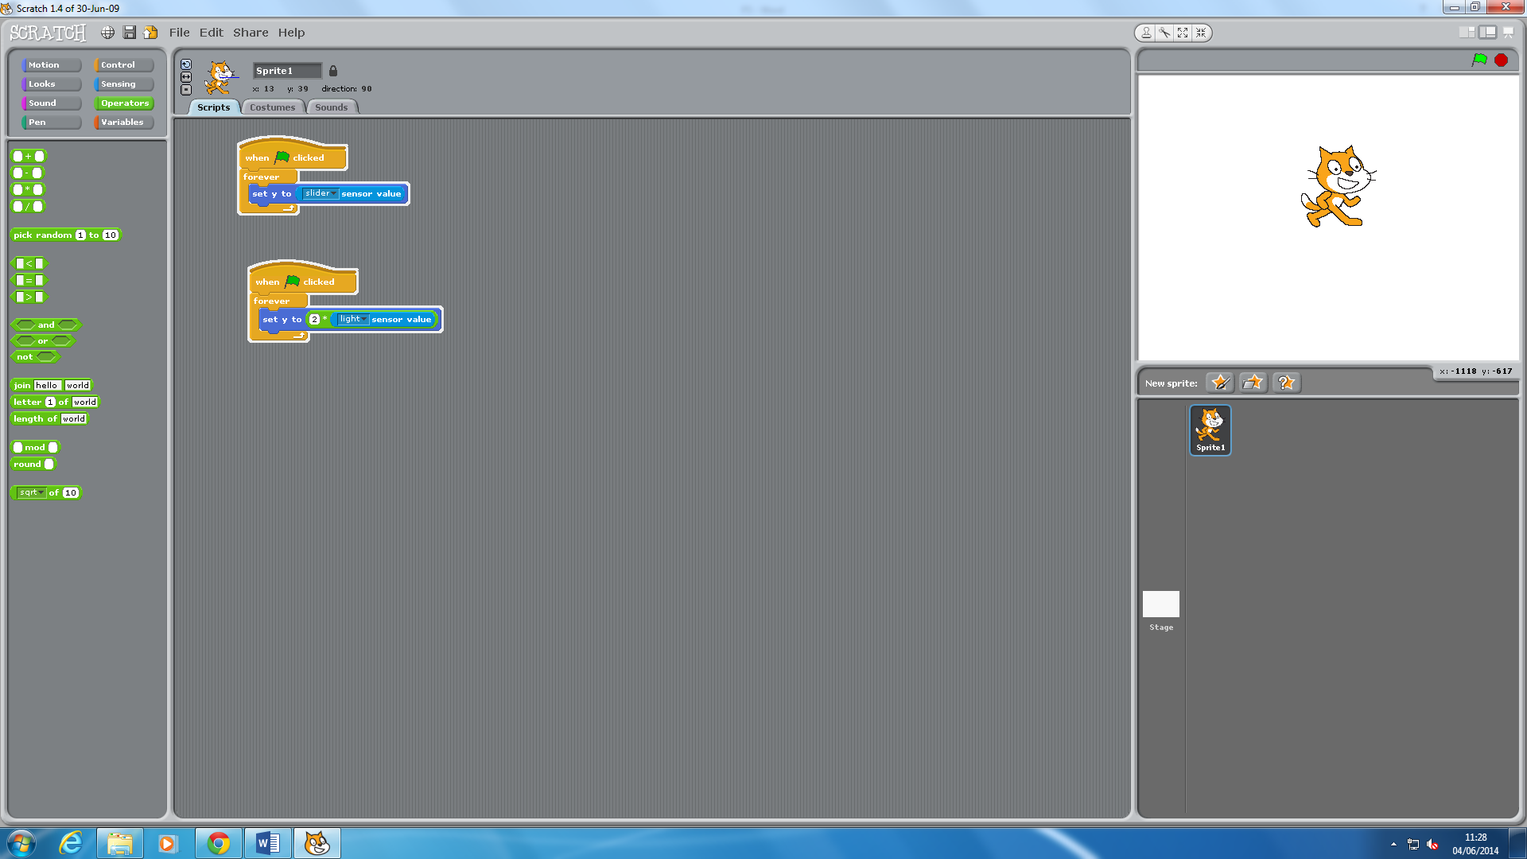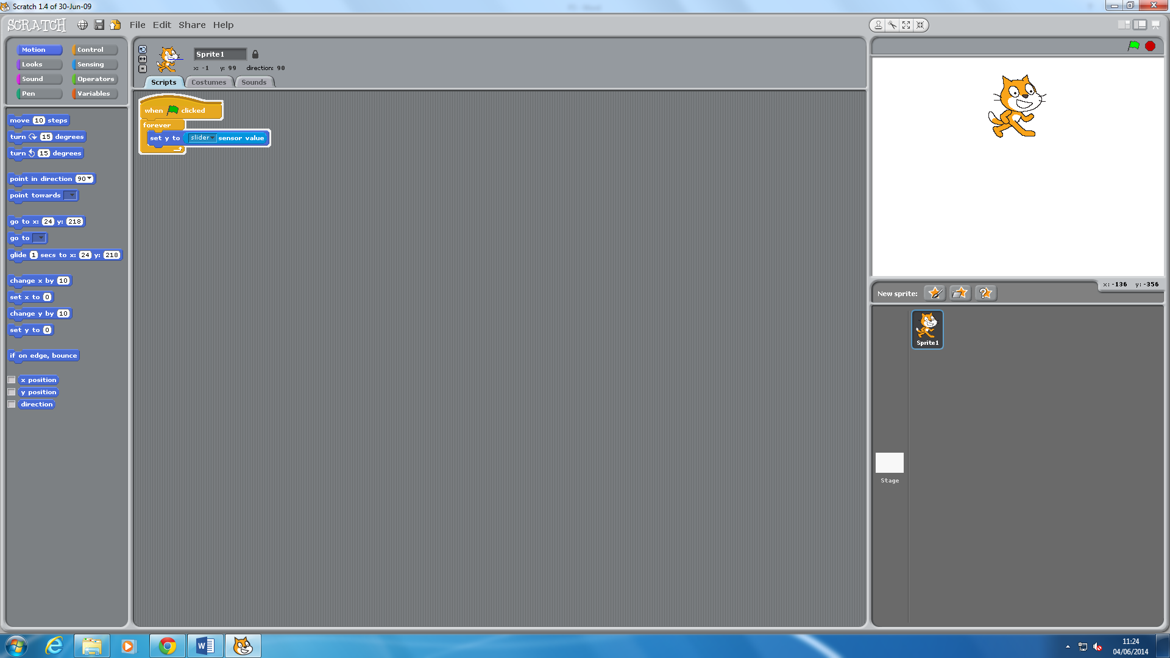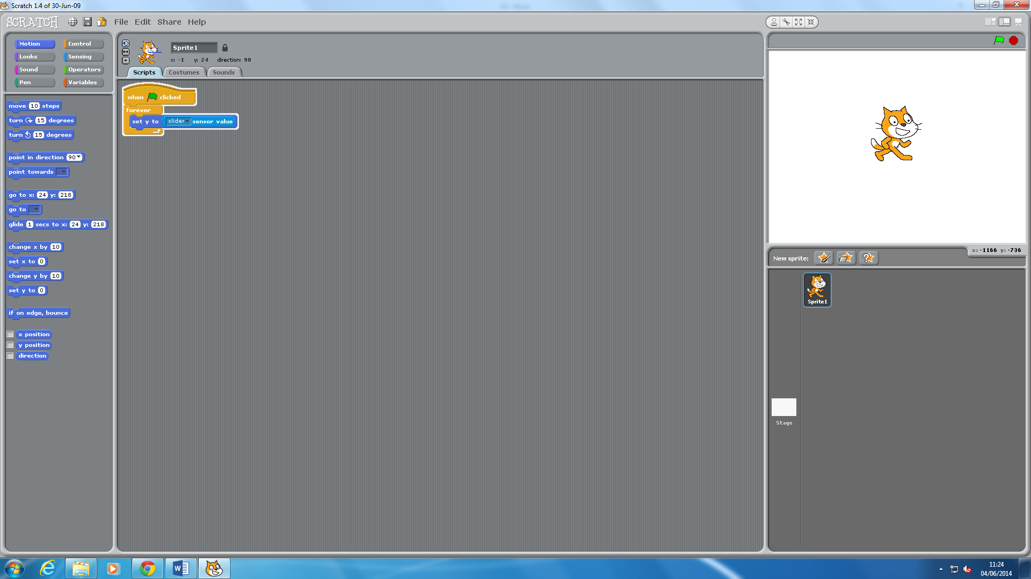

**PART 1**

This slider sensor allows the character to move forward and back whilst the slider is physically being moved. As you can see, it says ‘when clicked’, the sensor will move. As you can see, the character has been moved from one place to another. This is because the sensor is working properly.

**PART 2**

This is the light sensor and as if the user creates a shadow above the sensor, the reading will change.

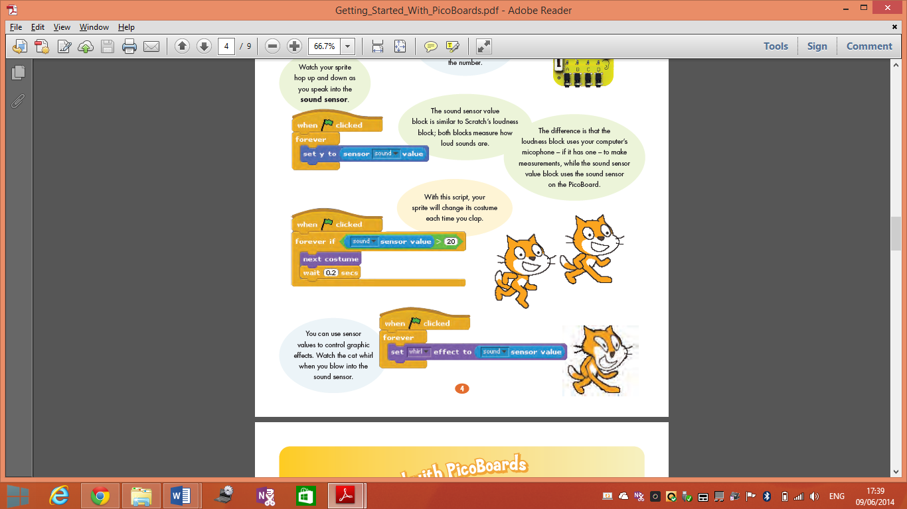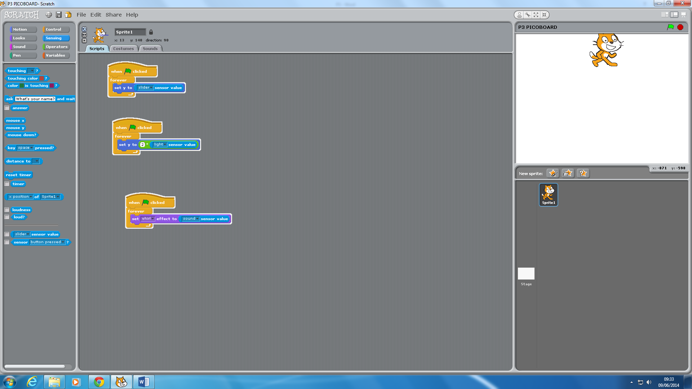

**PART 3**

This is the sound sensor where it is set to change its character suppose to ‘whirl’ once the user blows into the sound sensor. It only works once it has been detected. The process below shows how it works.

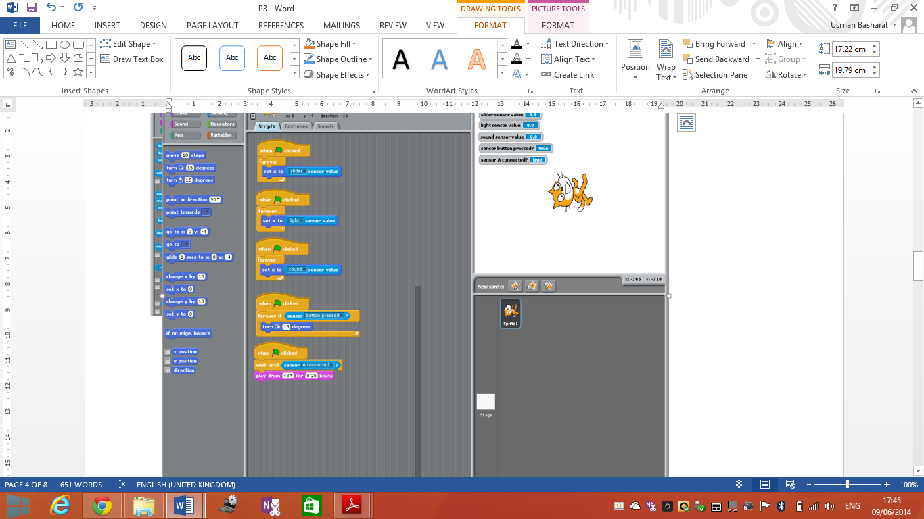

**STEP 4**

This is the sensor when the character turns ’15 degrees’ when the button has been pressed on the Pico board.





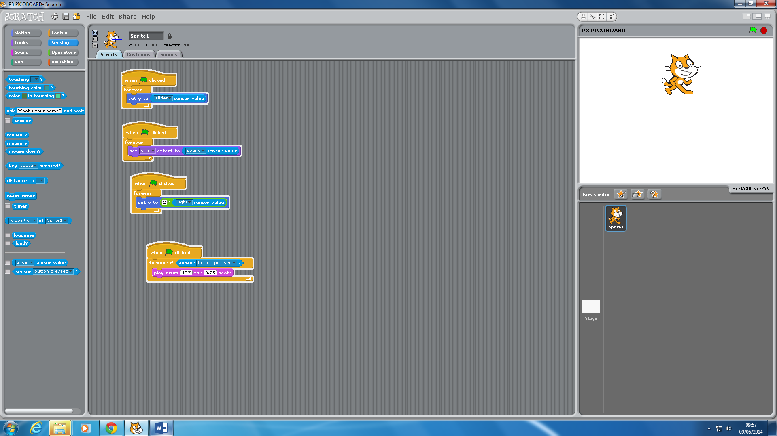

**PART 5**

This is the part where the sensor detects any metal that has been attached to port A. I used the corrodible clips for it and used my keys. As soon as I touched it with the metal, the beats started playing.

In addition, the second picture shows that once it has been connected, you can use the alligator clips to any of metal.

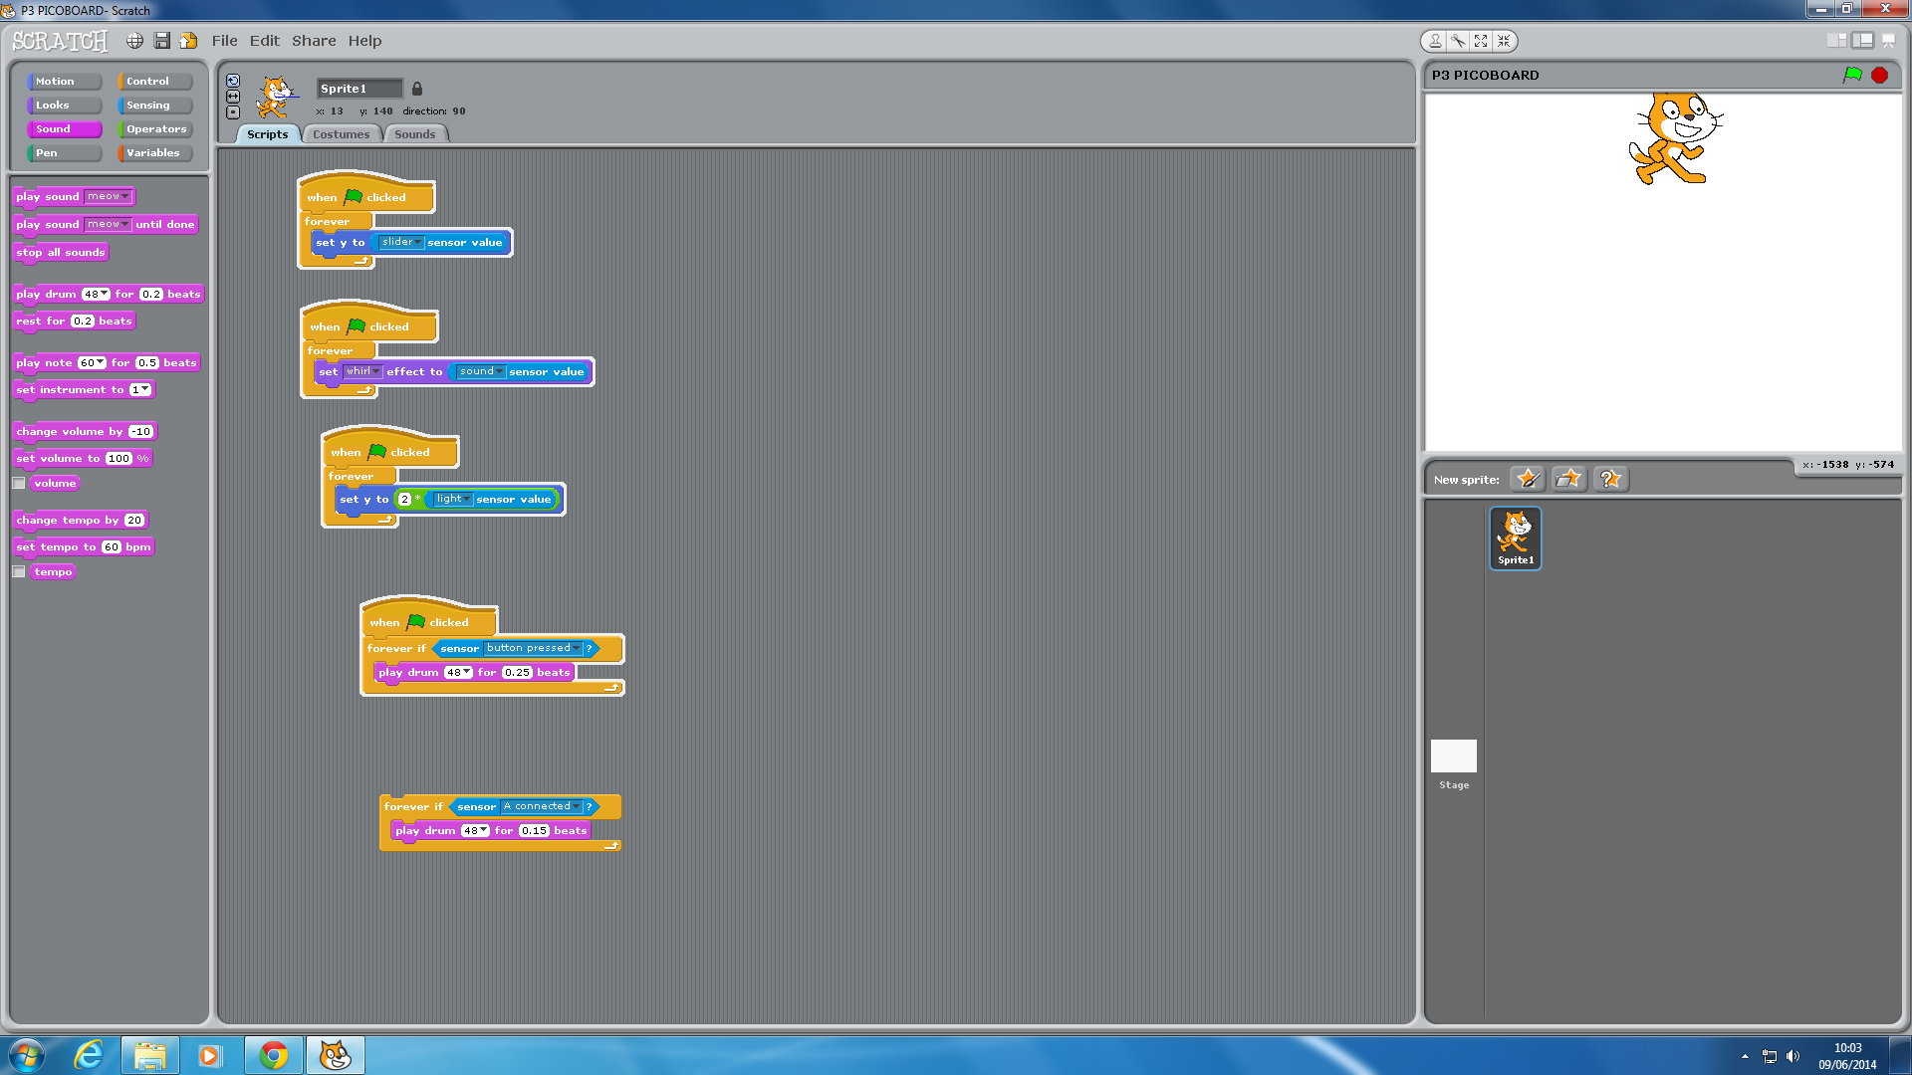

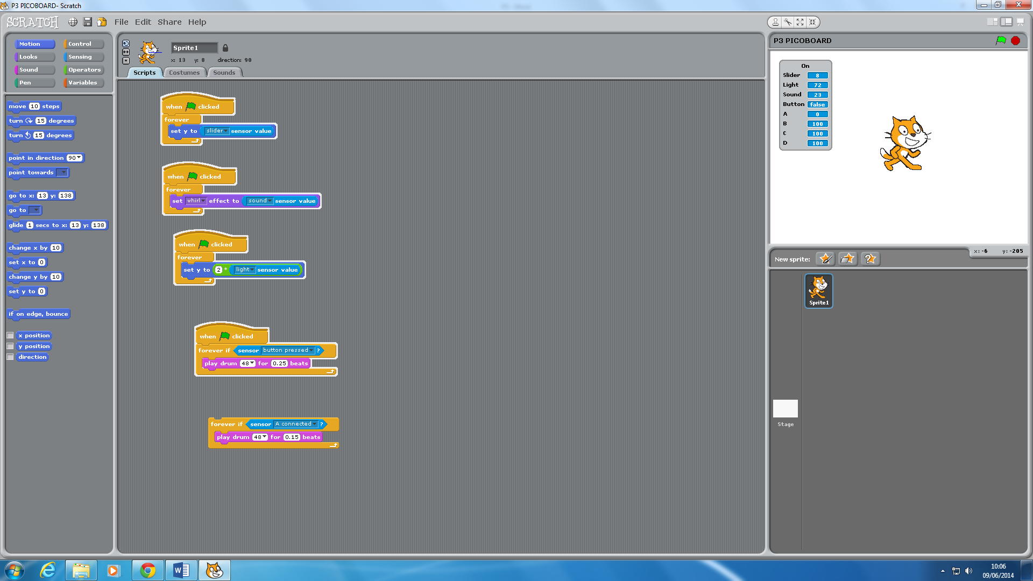

**PART 6**

This is the part where the user can check all of if all of the sensors are working at once. To do this, you will need to go on; ‘sensing’ and right click on the ‘sensor value’. Click on the option, ‘show scratchboard watcher’. This will appear. To close this, you will need to right click on it and choose the option, ‘close this port’. It will turn off and you can turn it on and off when you want.

